Task 1

<!DOCTYPE html>

<html lang="en">

<head>

<meta charset="UTF-8">

<meta name="viewport" content="width=device-width, initial-scale=1.0">

<link rel="stylesheet" href="style.css">

<title>Document</title>

</head>

<body>

<div>

<div class="text">

<h4>Start CSS Excercise</h4>

<p>good luck !</p>

</div>

<div class="btn">

<button> Start CSS Excercise ></button>

</div>

</div>

</body>

</html>

body{

background-color: black;

}

.text

{

color: white;

}

.text h4

{

font-size: 27px ;

}

.text p

{

margin-bottom: 30px;

}

.btn button {

color: white;

font-size: medium;

background-color: green;

border: 2px solid green;

width: 200px;

height: 50px;

border-radius: 3px;

}

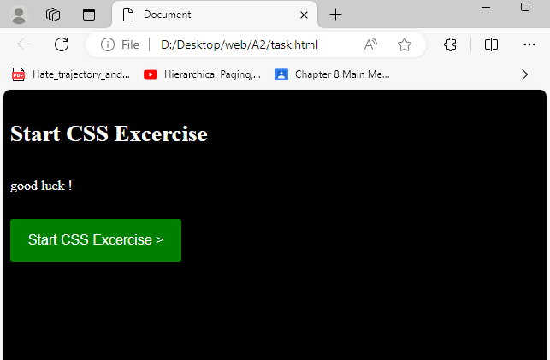

Task 2

<!DOCTYPE html>

<html lang="en">

<head>

<meta charset="UTF-8">

<meta name="viewport" content="width=device-width, initial-scale=1.0">

<link rel="stylesheet" href="style.css">

<title>login</title>

</head>

<body>

<div class="container">

<form action="">

<div class = "inputbox">

<input type="text" placeholder="NAME*">

</div>

<div class = "inputbox">

<input type="text" placeholder="USERNAME*">

</div>

<div class = "inputbox">

<input type="password" placeholder="PASSWORD*">

</div>

<div class = "inputbox">

<input type="number" placeholder="NUMBER*">

</div>

<div class = "inputbox">

<input type="email" placeholder="EMAIL_ID *">

</div>

<button type=" submit" class="btn"> REGISTER

</button>

</form>

</div>

</body>

</html>

body{

display:flex;

background-color: rgb(71, 71, 117);

justify-content: center;

align-items: center;

min-height: 100vh;

border: solid black;

}

.container .inputbox

{

width: 100px;

height: 40px;

margin : 20px;

}

.inputbox input

{

width: 500px;

height: 30px;

font-weight: 400;

font-size: 19ox;

}

.container button

{

width: 520px;

color: white;

height: 40px;

background-color: rgb(70, 55, 55);

margin-left: 18px;

align-items: center;

}

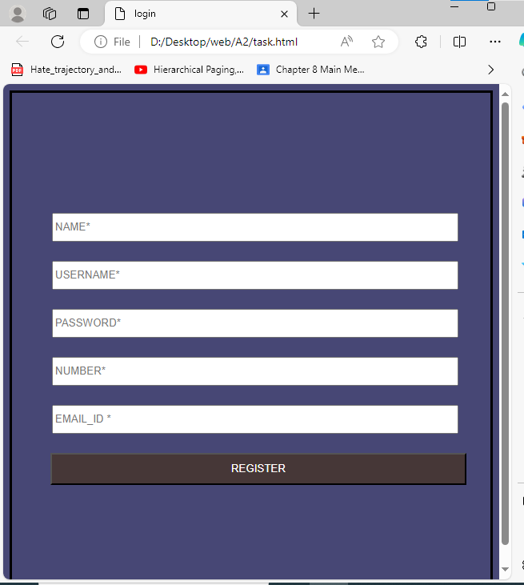

Task 3

<!DOCTYPE html>

<html lang="en">

<head>

<meta charset="UTF-8">

<meta name="viewport" content="width=device-width, initial-scale=1.0">

<link rel="stylesheet" href="style.css">

<title>login</title>

</head>

<body>

<div class="container">

<img src="img.jpg" alt="pic">

<div class="text">

<p>KOREA</p>

</div>

</div>

</body>

</html>

body {

font-family: Arial, sans-serif;

margin: 0;

padding: 0;

background-color: #f4f4f4;

}

.container {

display: flex;

flex-direction: column;

justify-content: center;

align-items: center;

height: 100vh;

}

.container img {

width: 50%;

border-radius: 4px;

border: solid 1px #a19b9b;

border-radius: 1%;

box-shadow: 0 4px 8px 0 rgba(0, 0, 0, 0.2);

}

.text p {

font-size: 20px;

font-weight: bold;

color: #1d1919;

text-align: center;

}

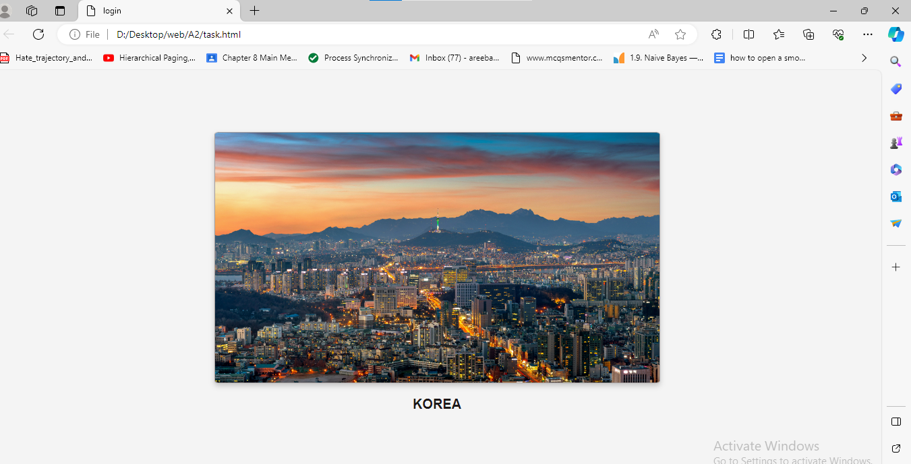

Task 4

<!DOCTYPE html>

<html lang="en">

<head>

<meta charset="UTF-8">

<meta name="viewport" content="width=device-width, initial-scale=1.0">

<link rel="stylesheet" href="style.css">

<title>login</title>

</head>

<body>

<div class="container">

<img src="img.jpg" alt="pic">

<div class="text">

<p>KOREA</p>

</div>

</div>

</body>

</html>

body {

font-family: Arial, sans-serif;

margin: 0;

padding: 0;

background-color: #f4f4f4;

}

.container {

display: flex;

flex-direction: column;

justify-content: center;

align-items: center;

height: 100vh;

}

.container img {

width: 50%;

border-radius: 4px;

border: solid 1px #a19b9b;

border-radius: 1%;

animation-duration: 3s;

animation:slidefromLeft 0.2s;

position: relative;

box-shadow: 0 4px 8px 0 rgba(0, 0, 0, 0.2);

}

.text p {

font-size: 20px;

font-weight: bold;

color: #1d1919;

text-align: center;

}

@keyframes slidefromLeft {

from {

left:-100%;

}

to {

left: 0;

}

}

